- Purpose
  - The purpose of this document is to describe the procedure for assembling the base on an orbital machine.
- Scope
  - This SOP applies to all equipment assembly team members. The process applies to the following machine ID’s:
E088066EQM0600BA1000 – Basic Sand Dragon 20, Orbital Sander 20”
E088066EQM0600BE1200 – Crewman 20 ORB, Orbital Strip Machine 20”
E088066EQM0607BA1000 – Basic Sand Dragon 20, Orbital Sander 20” Canadian
E088066EQM0607BA1000 – Crewman 20 ORB, Orbital Strip Machine 20” Canadian
E088068EQM0600BA1000 – Basic Sand Dragon 20, Orbital Sander 20” w/ Weights
E088068EQM0600BE1200 – Crewman 20 ORB, Orbital Strip Machine 20” w/ Weights
E088068EQM0607BA1000 – Basic Sand Dragon 20, Orbital Sander 20” w/ Weights Canadian
E088068EQM0607BA1000 – Crewman 20 ORB, Orbital Strip Machine 20” w/ Weights Canadian
E088068EQM0600ST4040 – Stanley Steemer Orbital Sanding Machine
E088070EQM0600BA1000 – Basic Sand Dragon 28, Orbital Sander 28” w/ Weights
E088070EQM0600BE1200 – Crewman 28 ORB, Orbital Strip Machine 28” w/ Weights
E088070EQM0607BA1000 – Basic Sand Dragon 28, Orbital Sander 28” w/ Weights Canadian
E088070EQM0607BA1000 – Crewman 28 ORB, Orbital Strip Machine 28” w/ Weights Canadian
- Responsibilities
  - The operations manager/supervisor is responsible for enforcing this SOP.
- Materials
  - The proper materials needed for this process are listed on the machine work order.
  - Hand/Power Tools
- Definitions

- Procedure
  - The process starts with a cast base (89611 for a 20” machine or 89652 for a 28” machine). Place the base upside down on a table. There is a threaded hole on the inside of each wheel mount that may need tapped out. Occasionally paint or other debris can get onto the threads.

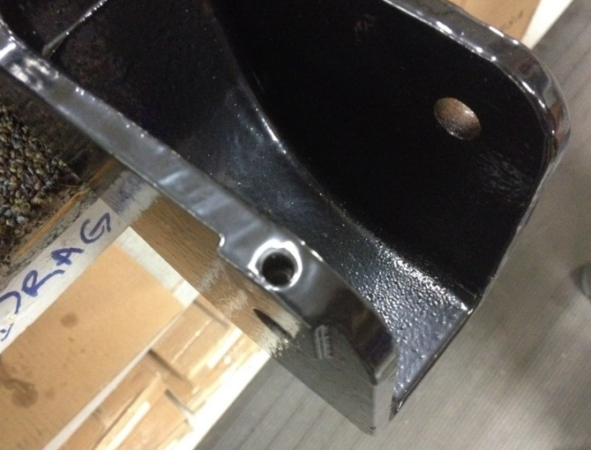
  - Take a handle support axle (89677) and place it through the hole on the base as shown. On the inside of the support place a nylon washer (83145) over the axle.

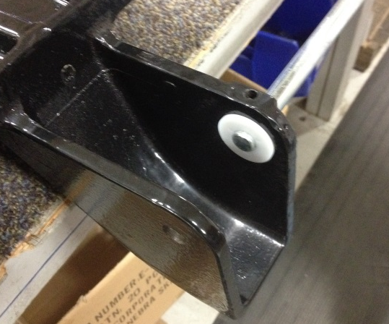

  - Place a wheel (12689) inside of the support and start to feed the axle through it.

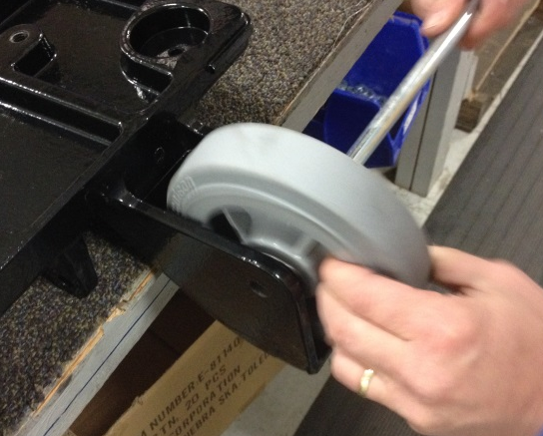

  - Place another nylon washer between the wheel and the support. This can be tricky. Once that is done, feed the axle through the 2nd support wall, but no further. This will hold the 1st wheel in place.

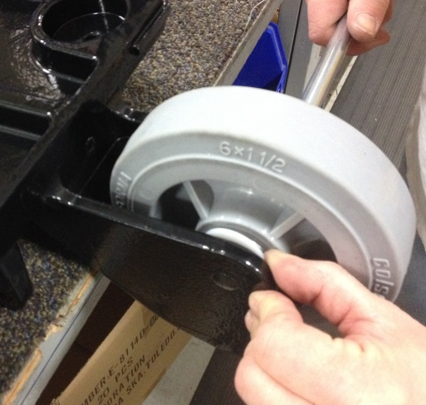
  - Take a handle support weldment (89659) and place a step bushing (89669) into each end of the tube as shown.

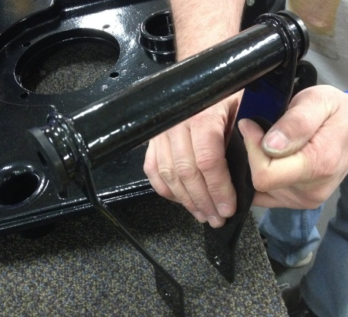

  - Place the weldment between the two wheel supports on the base as shown. Push the axle through it until it starts to go into the 2nd wheel support.

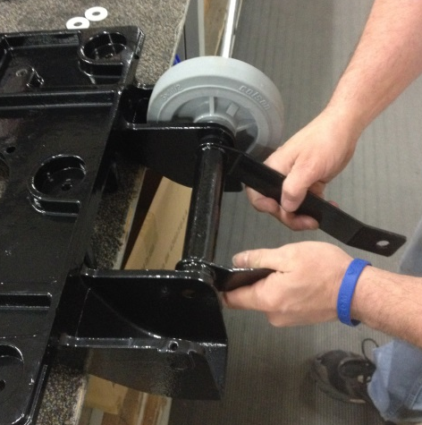

  - Install another wheel (12689) with a nylon washer (83145) on each side into the 2nd wheel support. Push the axle through this so that the entire assembly holds together. Center the axle.

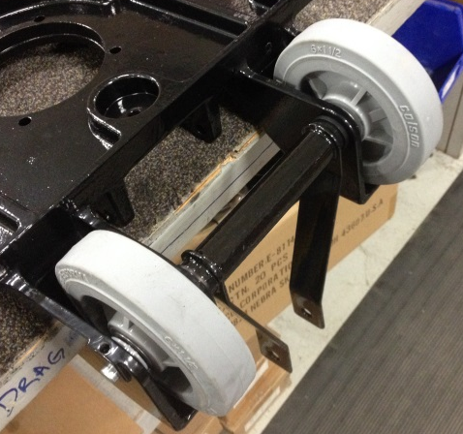
  - Secure the axle by threading 2 set screws (89678) into each end of the base. This means 4 total set screws. Place blue Loctite onto the threads prior to installation. The two set screws in each hole help to lock them in place.

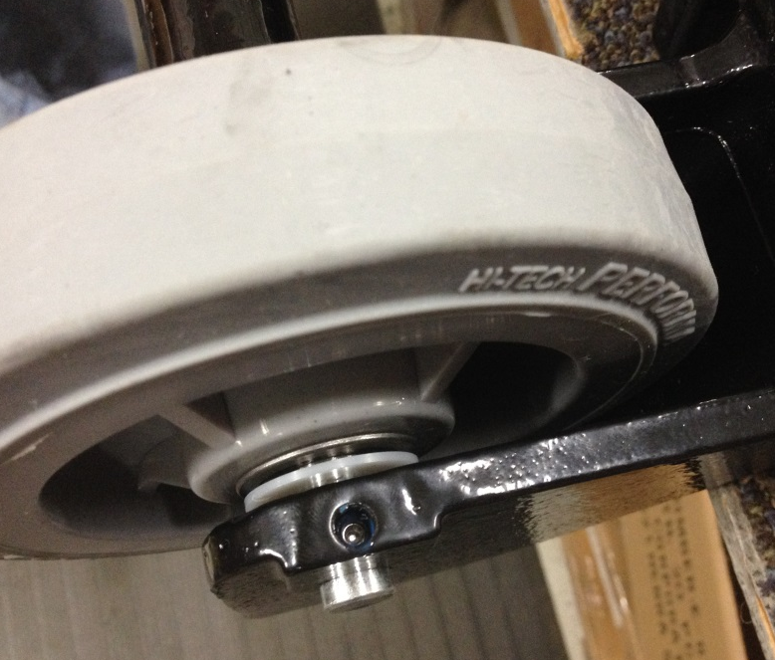

  - Place a bumper around the outer edge of the base. Use 89613 for a 20” machine or 89674 for a 28” machine. The bumper may be difficult to stretch around the edge. A pry bar may be needed to assist.

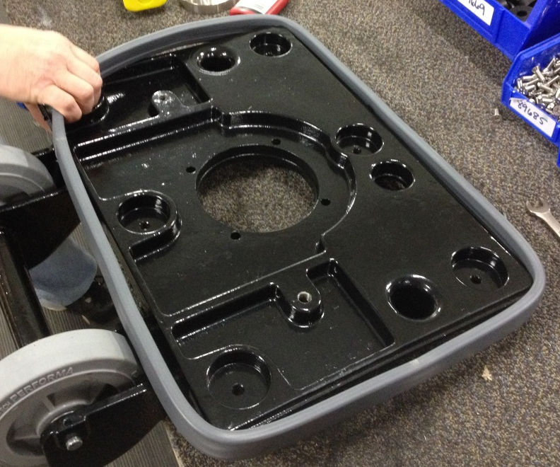

  - Base assembly is now complete.

- References (optional section as needed)

- Training Guide

Functional Training Groups Requiring Training
Equipment Assembly Group

- SOP Change Control

Date of Change | Reason for Change
4/28/2015 | This is the first version of the S.O.P. hence there are no revisions to this document.
1/16/2018 | Added the Responsibilities Section

Approvals

Submitter/Author Approval:__________________________________ Date:______________________

Management Approval:______________________________________ Date:______________________

QAU Approval:_____________________________________________ Date:______________________

